**Get All Players**

SELECT * FROM player

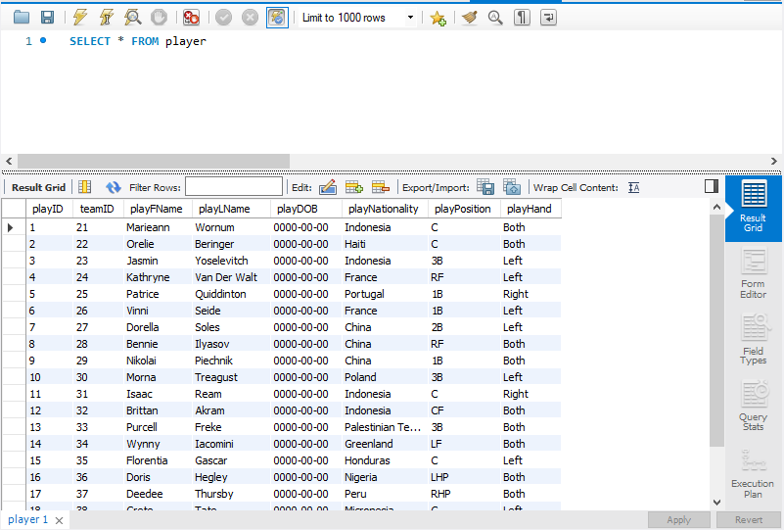

**Get all Catchers in the Organization**

SELECT * FROM player

WHERE playPosition = C

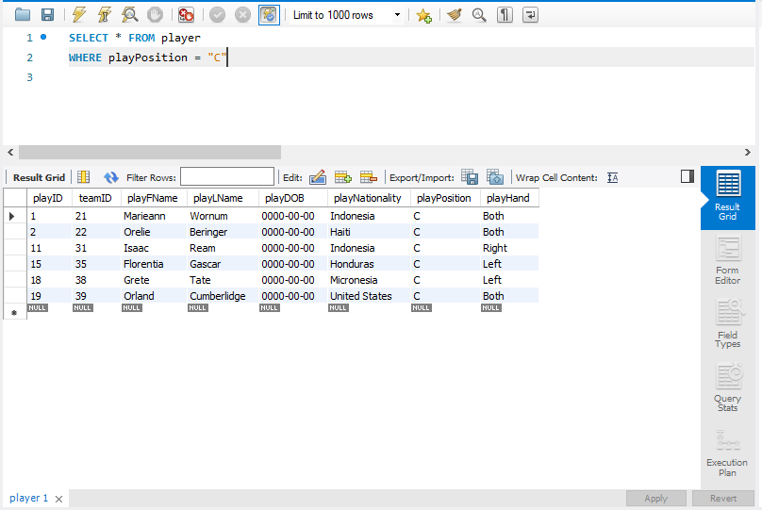

**Get a player and his team and return the team name alongside the players info.**

SELECT playID, playFName, playLName, team.teamCity, team.teamName

FROM player as player

JOIN team as team

ON player.teamID = team.teamID

WHERE playID = 1

This query looks weird because the team name is an auto generated species and the team city is most likely not from america because it was also auto generated.

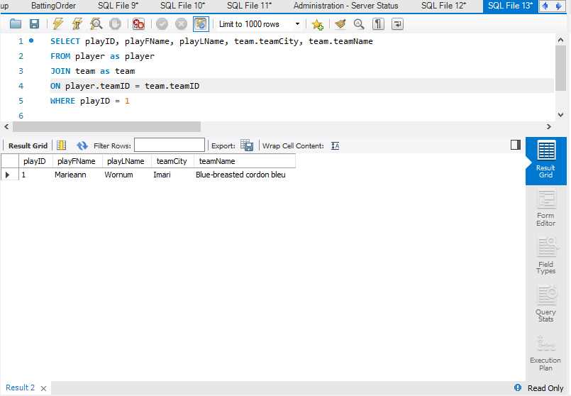

**Get all Players from China**

SELECT * FROM player

WHERE playerNationality = “China”

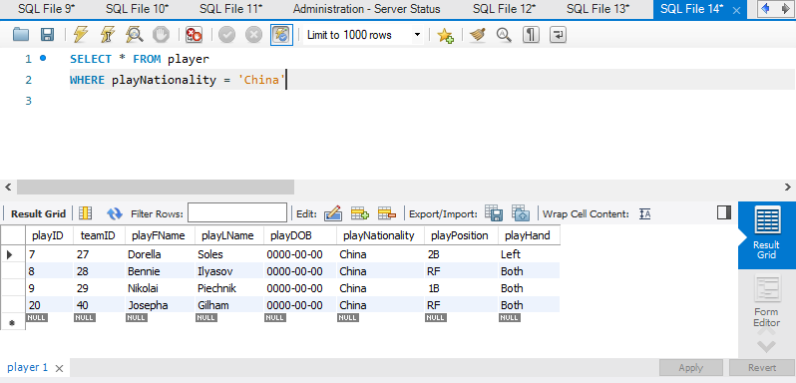

**Get all contracts and sort by Contract Value**

SELECT * FROM contract

ORDER by conTotal desc

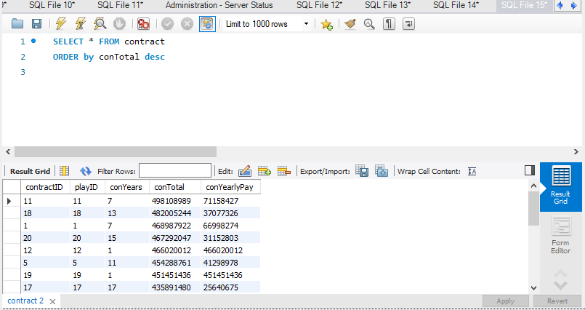

**Get a player and their contract and return some information from both tables**

SELECT player.playID, playFName, playLName, conTotal, conYearlyPay, conYears

FROM contract as contract

JOIN player as player

ON contract.playID = player.playID

WHERE player.playID = 5

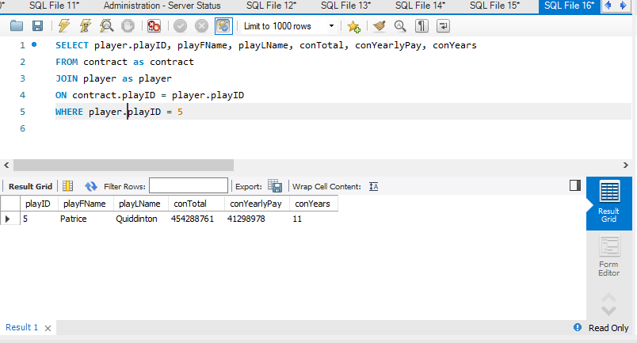

**Get all Injuries**

SELECT * FROM injury

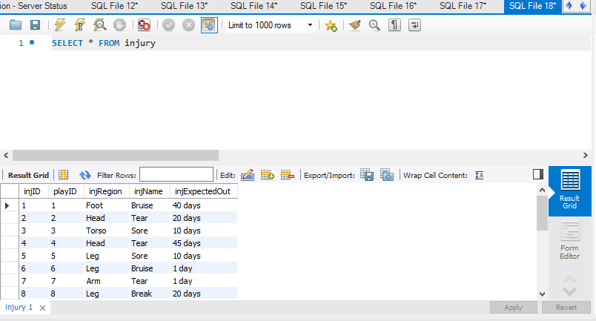

**Get all injuries to the leg to see if the team can prevent these injuries.**

SELECT * FROM injury

WHERE injRegion = 'Leg'

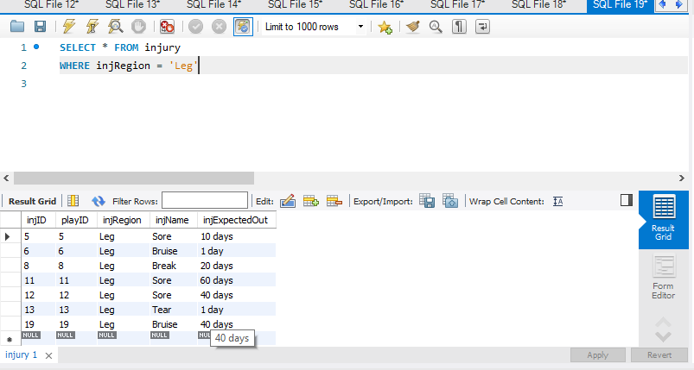

**Get all head injuries and sort by expected time out**

SELECT * FROM injury

WHERE injRegion = ‘Head’

ORDER BY injExpectedOut desc

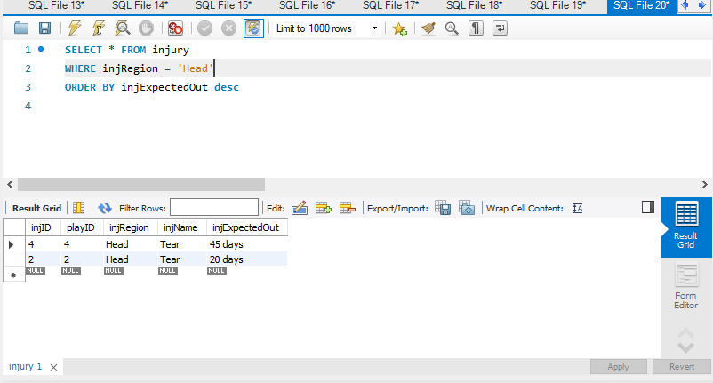

**Get all Contracts**

SELECT * FROM contract

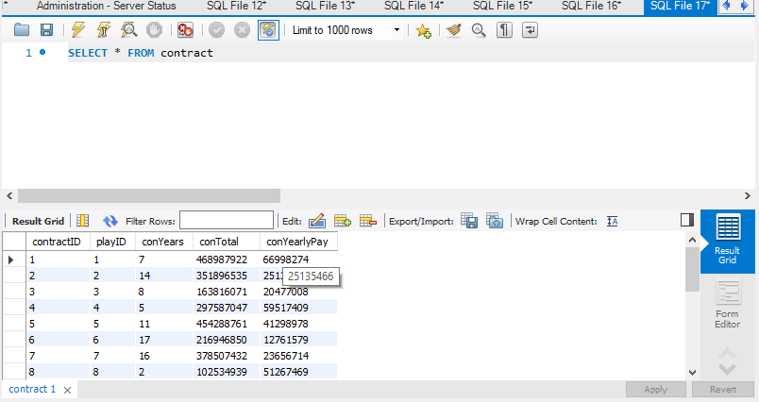

**Get all contracts between 0 and 5 Years, sometimes it is better to trade a player before their contract runs out.**

SELECT * FROM contract

WHERE conYears BETWEEN 0 AND 5

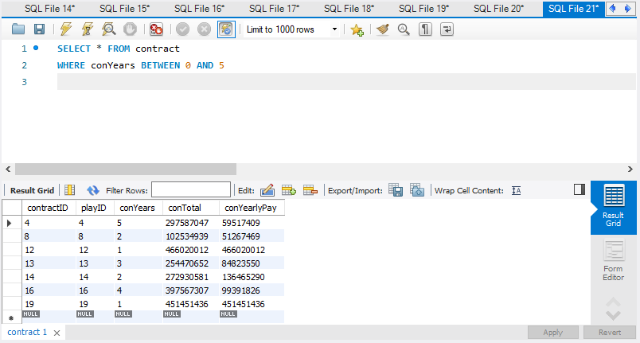

**Get all Games on the Schedule**

SELECT * FROM schedule

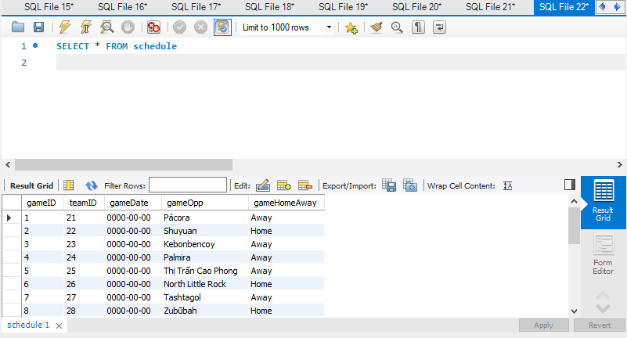

**Get all Away games from the schedule**

SELECT * FROM schedule

WHERE gameHomeAway = Away

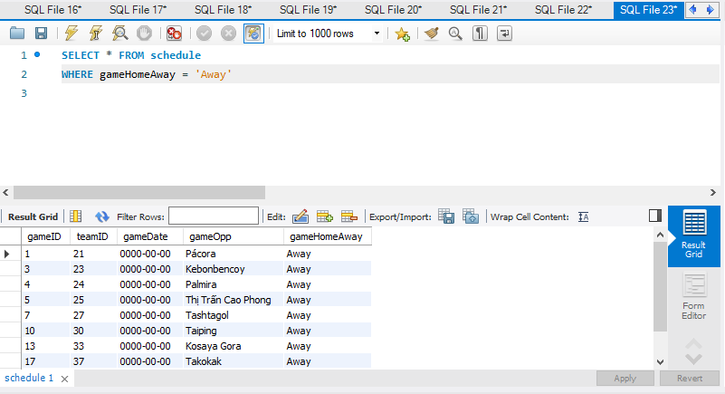

**Get the Player info of every player in the starting lineup**

SELECT player.playID, playFName, playLName, playPosition, slPosition

FROM startinglineup as sl

JOIN player as player

ON sl.playID = player.playID

There are two positions because you may sign a player to play catcher but they also may have to fill a spot of someone else is injured.

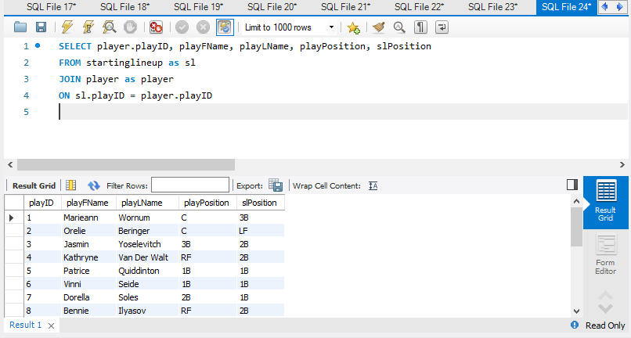

**Get the Player info of every player in the batting order**

SELECT player.playID, playFName, playLName, playPosition, boNumberInOrder

FROM battingorder as bo

JOIN player as player

ON bo.playID = player.playID

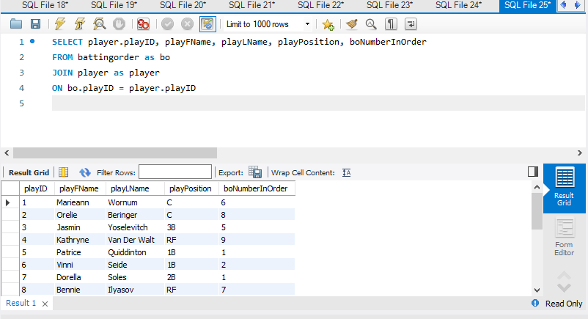

**Get all Teams**

SELECT * FROM team

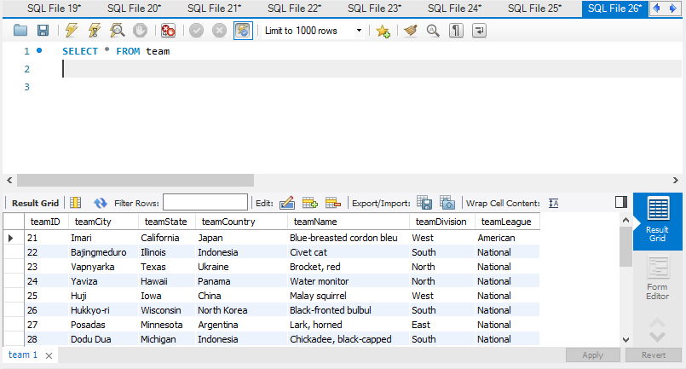

**Get all teams from the North Division**

SELECT * FROM team

WHERE teamDivision = 'North’

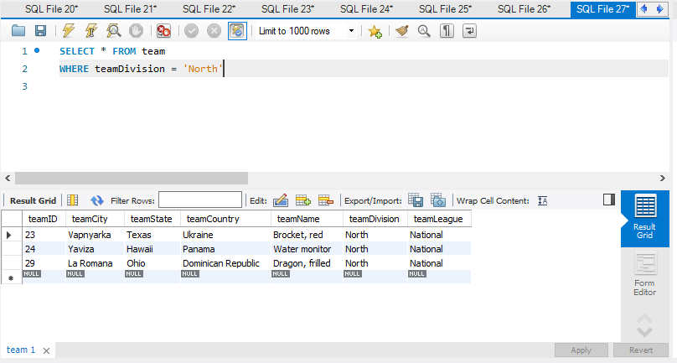

**Get all Players and their contract information then order by how many years are in the contract**

SELECT player.playID, playFName, playLName, playPosition, conYears, conTotal, conYearlyPay

FROM contract as contract

JOIN player as player

ON contract.playID = player.playID

ORDER by conYears desc

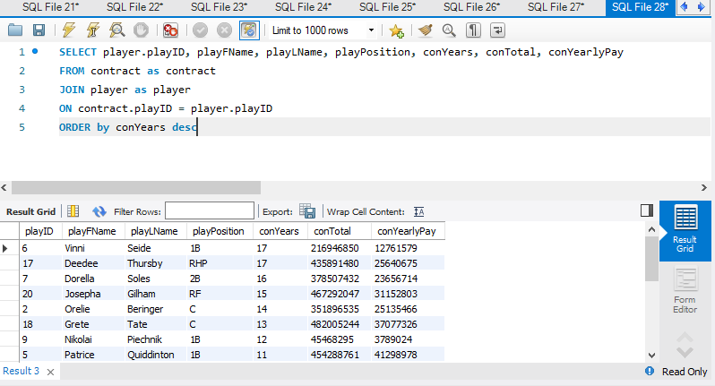

**Get all injuries and sort by expected return to see who needs to be reintegrated into practices and games.**

SELECT player.playID, playFName, playLName, playPosition, injRegion, injExpectedOut

FROM injury as injury

JOIN player as player

ON injury.playID = player.playID

ORDER by injExpectedOut

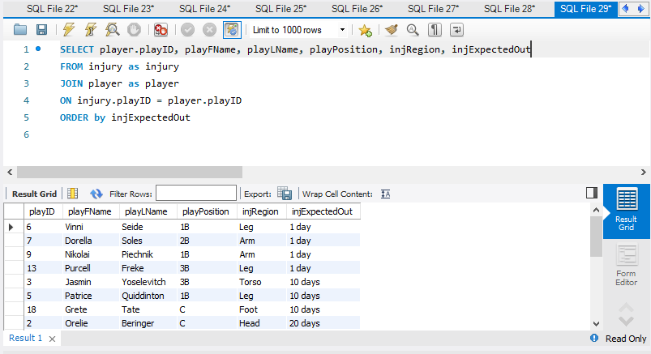

**GET all players on a team in the north division**

SELECT player.playID, playFName, playLName, playPosition, teamCity, teamName, teamDivision

FROM team as team

JOIN player as player

ON team.playID = player.playID

Where team.teamDivision = 'North'

Once again the output looks weird because of auto generated team cities and team names.

